 If you are creating a new academic unit, review this list of required information and have each item prepared:

- Related program of study to connect to the new academic unit
- Chairperson to connect to the new academic unit
- Academic unit name, code and CIP code
- Standard start date of the academic period in which the new academic unit change begins

Editing or adding an academic unit has profound impacts throughout your Workday Student tenant. Before editing or adding an academic, conduct the following:

- Discuss all changes with HR/FIN colleagues. Supervisory Orgs may need to be adjusted/created.
- Discuss all changes with Information Services to evaluate integration impact.
- Discuss with other offices (Financial Aid, Student Finance)

Use this reference edit or add an Academic Unit in Workday Student

Table of Contents:

INSTRUCTIONS – Editing an Existing Academic Unit 1
STEP ONE: Locate Academic Unit 1
INSTRUCTIONS – Creating a New Academic Unit 3
STEP ONE: Locate an existing academic unit to use as a template 3
STEP TWO: Create new Academic Unit 5
STEP THREE: Configure Academic Levels 6

INSTRUCTIONS – Editing an Existing Academic Unit

STEP ONE: Locate Academic Unit

- In the search bar, type “View Academic Unit”. Select the View Academic Unit report when it auto-populates.

- The View Academic Unit window will appear. In the Academic Unit field, click and select a unit in which to use as a template. Click “OK”.

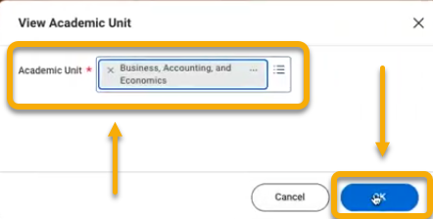

- The selected academic unit page will appear. Click the related actions button . Click “Academic Unit”. Click “Edit”.

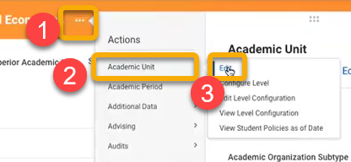

- The Edit Academic Unit window will appear. Edit the Effective Date field to be in the past or the current day. If you choose a future date you will not be able to complete all required steps. Click “OK”.

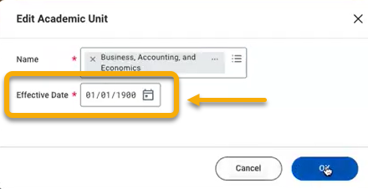

- Modify the name, code, or other fields as needed.

INSTRUCTIONS – Creating a New Academic Unit

STEP ONE: Locate an existing academic unit to use as a template

Be sure to complete this step in Sandbox so as not to inadvertently impact data.

- In the search bar, type “View Academic Unit”. Select the View Academic Unit report when it auto-populates.

- The View Academic Unit window will appear. In the Academic Unit field, click and select a unit in which to use as a template. Click “OK”. Note: In this example, Business, Accounting, and Economics academic unit is used as the template.



- The selected academic unit page will appear. Click the related actions button . Click “Academic Unit”. Click “Edit”.

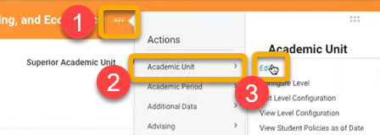

- The Edit Academic Unit window will appear. Locate the Effective Date field and change to “01/01/1900”. Click “OK”.



- The Edit Academic Unit page displays the same fields in the same format as the Create Academic Unit page. Ultimately, you will display both windows side-by-side and copy these details to create your new academic unit.

 DO NOT CHANGE any information on the Edit Academic Unit page. Simply view as a reference.
 Be sure you are in Sandbox. Here is an example of a portion of the Edit Academic Unit page.

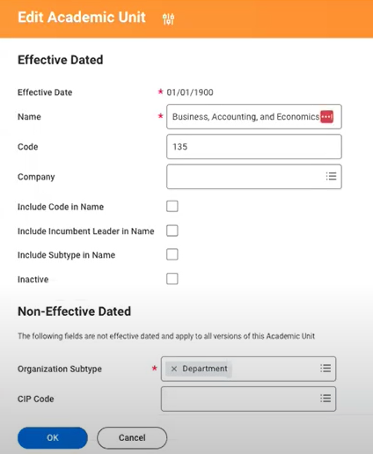

While keeping the Edit Academic Unit page open, open a new window and continue with the steps below.

STEP TWO: Create new Academic Unit

- In the search bar, type “Create Academic Unit” and select that Create Academic Unit task that auto-populates.

- In the Create Academic Unit page, locate the Effective Date field. Enter a date in the past or current day. For example, the date could be 01/01/1900 or the current day. Note: If you choose a future date you will not be able to complete all required steps.

- In the Name field, enter the name of the new Academic Unit.

- In the Code field, enter the code.

- In the Company field, you may see “Western Colorado University”. Remove this default selection and allow the field to remain blank.

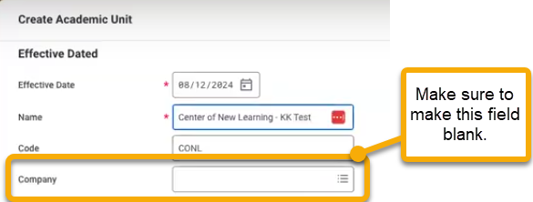

- With both the Edit Academic Unit page and the Create Academic Unit page in view, copy and complete the remaining required fields into the Create Academic Unit page. To do this, you may re-size both pages, so that you can see them side-by-side.

- Scroll down to the Assigned Roles table. Click the empty field in the Role column. Select “Academic Chair/Manager”.

- In the Assigned To column, click the blank field and enter the chair’s name.

- Before proceeding, take a pause. Review all fields and compare to the template to check your work. Check for typos and all other details. Do not rush.

- When finished, click “OK”.



STEP THREE: Configure Academic Levels

- The next page will display and confirm the new academic unit. Congratulations!

If the new academic unit will offer classes or programs of study, follow these steps.

Click the related actions button . Click “Academic Unit”. Click “Configure Level”.

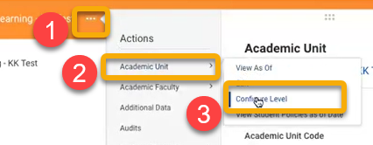

- On the Configure Academic Unit for Level window, click the Academic Levels Offered field and make a selection.

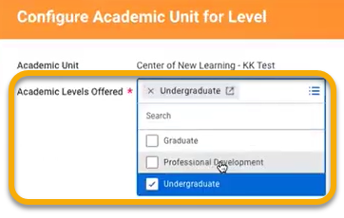

- Click “OK”.



- An Academic Unit Levels table will appear. To complete this table you will need to copy the table from the template academic unit previously used.

Follow these steps to locate and view the table on the template.

- Return to the Edit Academic Unit page. Do not click “OK”. Click “Cancel” to return to the previous and avoid saving changes.

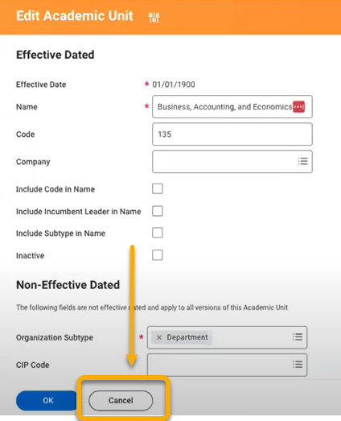

- You will return to the academic unit page of the template unit. Click the related actions button . Click “Academic Unit”. Click “View Level Configuration”.

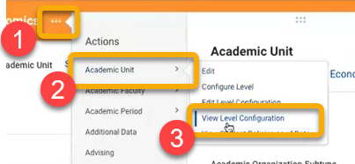

- The Academic Unit Levels table will appear. Note the dates in the First Entry Date and Effective Date. Note also the settings in the Configuration Options and Period Configuration columns.

Copy these settings into the Academic Unit Level table of the new academic unit.

Note: If the new academic unit will offer programs of study, be sure to click “Offer Programs of Study” in the Configuration Options column. If the academic unit will offer courses, be sure to click “Offer Courses”.

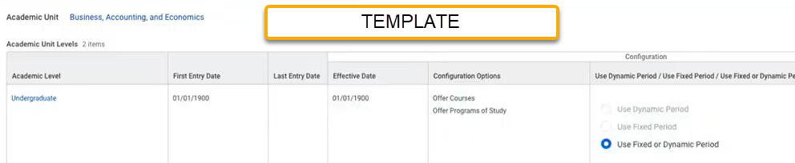

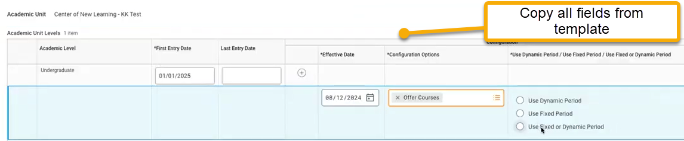

- When finished, click “OK”.

- If the new academic unit will NOT offer programs of study, you’re finished!

If the new academic will offer programs of study,

You run into hierarchy problems at timestamp: 34:00

